Pizza sales SQL Queries

1. KPI
2. Total Revenue

select sum(total_price) as total_revenue from pizza_sales

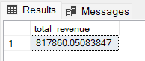

1. Average Order Value

select sum(total_price) / COUNT(distinct order_id) as Avg_order_Value from pizza_sales

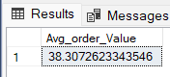

1. Total Pizzas Sold

select sum(quantity) as Total_pizza_sold from pizza_sales

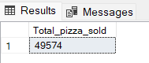

1. Total Orders

select count (distinct order_id) as total_orders from pizza_sales

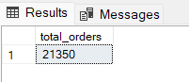

1. Avrerage Pizzas per Order

select CAST(CAST(sum(quantity) AS decimal (10,2)) /

CAST(count (distinct order_id) AS decimal (10,2)) AS decimal (10,2)) As Avergae_Pizzas_per_order

from pizza_sales

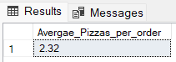

1. Daily Trend for Total Orders

SELECT DATENAME (Dw, order_date) as order_day, COUNT(DISTINCT order_id) AS Total_orders

from pizza_sales

GROUP BY DATENAME (Dw, order_date)

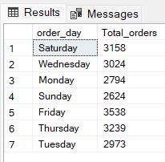

1. Hourly Trends for Orders

SELECT DATEPART(HOUR, order_time) AS order_hours, COUNT(DISTINCT order_id) AS Total_orders

from pizza_sales

GROUP BY DATEPART(HOUR, order_time)

ORDER BY DATEPART(HOUR, order_time)

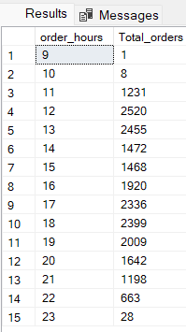

1. % Sales by Pizza Category

SELECT pizza_category,sum(total_price) as tptal_sales, sum(total_price) * 100 /

(SELECT sum(total_price) from pizza_sales WHERE MONTH(order_date) = 1)

AS PCT_Total_Sales

from pizza_sales SELECT pizza_size,CAST (sum(total_price)as DECIMAL (10,2)) as total_sales, CAST( sum(total_price) * 100 /

(SELECT sum(total_price) from pizza_sales WHERE MONTH(order_date) = 1)

as DECIMAL(10,2)) AS PCT_Total_Sales

from pizza_sales

WHERE MONTH(order_date) = 1

GROUP by pizza_size

ORDER BY PCT_Total_Sales DESC

WHERE MONTH(order_date) = 1

GROUP by pizza_category

ORDER BY PCT_Total_Sales DESC

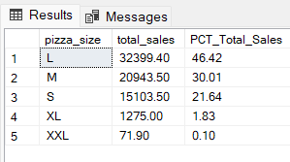

1. Pizzas sold by Category

SELECT pizza_category, sum (quantity) as total_pizza_sold

from pizza_sales

Group by pizza_category

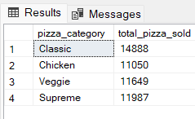

1. Top 5 Best Seller Pizzas

SELECT TOP 5 pizza_name, sum (quantity) as total_pizzas_sold

from pizza_sales

Group by pizza_name

order by sum(quantity) DESC

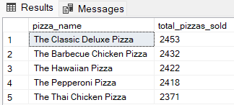

1. 5 Least Sold Pizzas

ELECT TOP 5 pizza_name, sum (quantity) as total_pizzas_sold

from pizza_sales

Group by pizza_name

order by sum(quantity) ASC

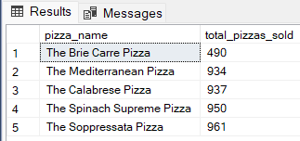

1. Top 5 Best Sellers in Janunary

SELECT TOP 5 pizza_name, sum (quantity) as total_pizzas_sold

from pizza_sales

WHERE MONTH (order_date) = 1

Group by pizza_name

order by sum(quantity) ASC

